Associational Discussion Meeting
March 29th
Christ Church Loughborough

We invite you to join with us at Christ Church Loughborough to discuss the plans for a future confessional Baptist association united in our common confession of the 2nd LCF 1677/89.

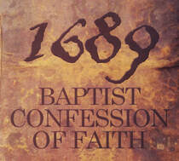

When: Tuesday March 29th 2021, 10:00 am - 5:00 pm
Where: 25a Herbert Street, Loughborough, LE11 1NU

Schedule:

10:00 Welcome and Update
10:30 Exhortation: The Necessity for a Confessional Association: Oliver Allmand-Smith
11:00 Discussion: Confessional Subscription
12:30 Lunch
1:30 Lecture: Baptists and Worship: Dr. Robert Strivens
2:30 Discussion
3:15 Break
3:30 Discussion
4:30 Corporate Prayer
For more information please contact Brett Shaw. Phone: 07754 692939
trinitygracechurch.net

