2025, February Internship Report
Dear brethren,
Receive my warm greetings in the Lord. Trusting that you are doing well, and pressing on in the fight of faith. May God’s mercy, peace and love be multiplied to you.
TBCN Ministries that I was Assigned
Early this month, I was requested to serve the following ministries:
(a) Daily Prayers
I was told to be accessing church’s website and to daily transferring the prepared prayer points to the Church Fellowship Group, so that the members would be daily having church’s prayer points to pray for. I thank God for this ministry. Would you pray with me that I may be faithful to serve God and His church in this way.
(b) School ministries
This is another ministry that I was assigned to lead. These are the nearby schools which the church used to minister since some years back. So, we have resumed this month, and as an intern I am to be actively participating as I encourage brethren to join me. Below are those schools:
- Carlin Primary: This is a young, new school, which carries few numbers of learners. Majorly, the bigger population of pupils are Muslims, but they do not join us during our fellowships. We meet every Wednesday morning in one of their classrooms. Since their gathering is one, therefore, they need one teacher, so I am the one assisting them. We had three lessons this month before they break for the half-term, and I taught the gospel from: John 3:16; John 1:1-5; and 2nd Corinthians 5:21. I have been thinking to go through catechism for boys and girls, with them. Pray for this ministry that God’s Word may work in the hearts of these children and in their teachers.
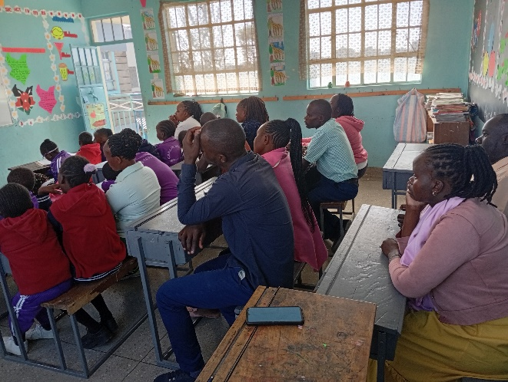
This is one of the class photo
- Donholm Primary: This school is another gospel opportunity. The school has a good number of children. Their administration is very receptive to the Christian teachings, so, they agreed to give us 31 separate gathering of pupils every week (19 on Monday, and 12 on Friday). Since I cannot alone be able to administer to these groups, our church members have been of good use to join me teaching them. You may pray for us (the church) that we should be zealous to respond to this Macedonian call.
Church Activities
Below, are number of church activities that I have participated at. I am very joyful to learn through observations, hearing and interactions during this ministry. It is my prayer that, there may be found more alike opportunities, so that I may learn much.
(a) Interview for Membership
One weekday, I was invited by our pastor to join him interviewing a lady who was interested to join the church. This became a good opportunity for me to be part of interviewers for the first time; listening to her, asking questions, and observing the whole process on how pastor approached the matter until he closed with the Word of prayer.
(b) Collection of offerings
This was another opportunity that Pastor Domnic, not only needed help from me for accountability, but also that I may learn how to be of good use in the future regarding transparency. Three of us were involved in the collection, counting, confirmation and signing. I realized that at least one pastor, deacon and some witnesses must be present during every offering collection. I was so happy to learn this way of accountability.
(c) Witnessing exchange of vows
I lack words to express my heartfelt gratitude regarding the great opportunity of witnessing the fellow brethren being joined in a godly way. I was amazed to see how every elder at the pulpit (during weddings) begins with the purposes of marriage, duties of the candidates and then finishes with the evangelistic sermon to the congregation.
(d) Weekly ministries
I appreciate the privilege for me at TBCN; for I am currently experiencing the benefits from such well-established church: sitting under the good preachings every Sunday, observing the good order of services, enjoying the fellowship of matured saints, and seeing how the church created many opportunities for fellowships (e.g., mid-week meetings and ministries). Pray for me that this ministry may draw me closer to God; to desire and know Him more.
TPC
I have been struggling to work faster my TPC assignment, but currently, I am putting more effort to catch up. I am done with the three letters (Hebrews, James and 1st Peter), and the first five unit of homiletics. Therefore, I have been left with the last five units of homiletics. Please pray with me, while I am working hard to complete them soon.
Our upcoming classes are drawing near, 12th March. We will be taught the Exegesis and Hermeneutics. The lecturer is Nate Davidson. Please pray for him as he continues preparing. Pray for all students too, that we may complete previous work.
In Christ,
Muketi.

