NOVEMBER 2020 TPC REPORT

Concerning the classes held between the 11th and 18th of November 2020.

‘Do your best to present yourself to God as one approved, a worker who has no need to be ashamed, rightly handling the word of truth.’ 2 Tim. 2:15

A Picture Of The Online Classroom

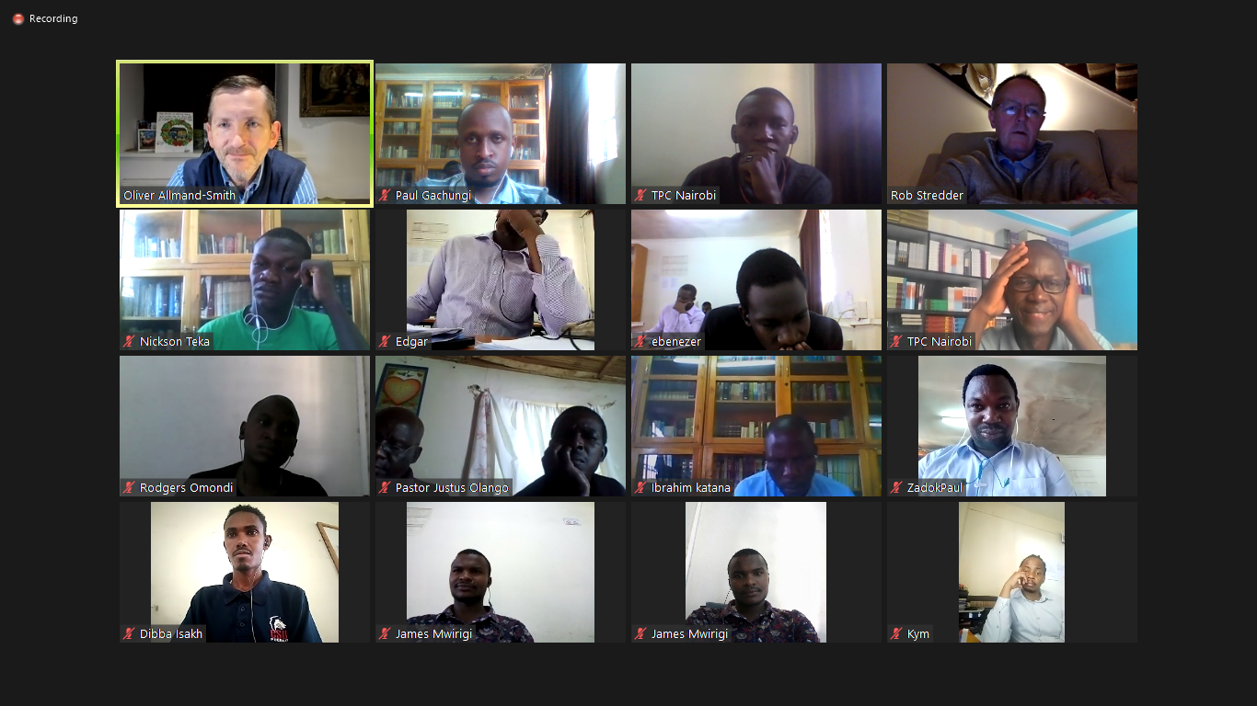
[From top left: Pst Oliver, Paul, Kahure, Pst. Rob, Teka, Edgar, Ebenezer, Pst. Eric, Rogers, Aloice, Justus, Ibrahim, Zadok, Dibba, James, Kym]

As we come to the end of this academic year, we ought to thank God for it is He who has enabled us to complete all that has been accomplished this year.

Though the Coronavirus has meant that only two of our sessions this year have been conducted physically, we still thank God that we were able to have the classes virtually, even the class where our teacher was in a completely different time-zone. My prayer is that our classes will return to normal next year but if not, we will still trust in the Lord.

Pst. Oliver Allmand-Smith was our teacher and he taught two units: Unit V- Old Testament: Poets and Unit W- Evangelism. The classes were conducted via Zoom, thus, Pst. Oliver taught from his home/office in Ramsbottom UK. The persistence of the spread of the Coronavirus meant that he could not teach the classes physically due to the various restrictions that are in place in the UK.
The classes ran from 10 am to 5 pm every day and went on as scheduled during the entirety of the class. His use of time and organization meant that there was never a time that the students were concerned that he would not cover the whole material.

Pst. Oliver graciously gave us some of his notes which he thought would be beneficial to us in our studies and/or ministries. The notes on what to focus on in evangelism were most helpful to me and the other students.

He taught on Evangelism from Wednesday 11th to Monday 16th at lunchtime. The rest of the time was devoted to Old Testament Poets.

His method of teaching was interactive and was profitable to all since his firm and serious nature kept the interactions from going off-topic.

